Investment Assignment

Name
Institution of Affiliation
Professor
Date

Investment Assignment

5.
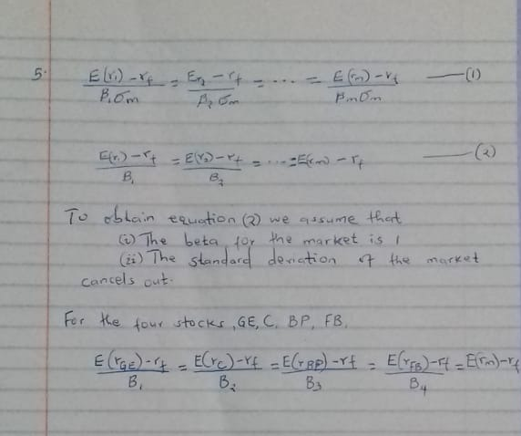

6. The market where the GE, FB, BP and C stocks are sold is ideal. All the investors in these stocks are risk averse. The investors can access information regarding the GE, FB, PB and C stocks easily as the markets are efficient. All the investors in any stock can borrow and lend any amount without limit as there is a risk-free rate. The assets are infinitely divided and absolutely liquid. the investors are price takers and return on assets face a normal distribution.
7. The market beta will increase resulting to increase in the market equilibrium. The expected return will increase relative to the required rate of return in the short run. In the long run, the market will adjust and the expected return will be equal to the required return. Some of the securities will be undervalued relative to others while others will be overvalued.

8. b) Beta = 0.696854
c) Alpha = 8.313294

